Program Information | [Lesson Title]  I Need More Information! | TEACHER NAME  Jackie Hamlett | PROGRAM NAME  OLRC
Program Information | [Unit Title]  Research | NRS EFL  2 – 4 | TIME FRAME  180 minutes

Instruction | ABE/ASE Standards – English Language Arts and Literacy
Instruction | Reading (R) |  | Writing (W) |  | Speaking & Listening (S) |  | Language (L)
Instruction | Foundational Skills | R.2.2, R.3.2 | Text Types and Purposes |  | Comprehension and Collaboration | S.2.1, S.3.1,  S.4.1 | Conventions of Standard English
Instruction | Key Ideas and Details |  | Production and Distribution of Writing | W.2.4, W.3.3,  W.4.3 | Presentation of Knowledge and Ideas | S.2.4, S.2.5 | Knowledge of Language
Instruction | Craft and Structure |  | Research to Build and Present Knowledge | W.2.7, W.3.6 |  |  | Vocabulary Acquisition and Use
Instruction | Integration of Knowledge and Ideas | R.2.11, R.3.15, R.4.10  R.3.17 |  |  |  |  | Benchmarks identified in RED are priority benchmarks. To view a complete list of priority benchmarks and related Ohio Aspire lesson plans, please see the Curriculum Alignments located on the Teacher Resource Center.

 | LEARNER OUTCOME(S)  - Learners will develop and improve their research skills by using a variety of available sources to investigate an issue of their choice. |  | ASSESSMENT TOOLS/METHODS  - Possible evidence could include a copy of the filled out activity worksheet, the self-assessment rubric, and the evaluation rubric filled out by the teacher.
LEARNER PRIOR KNOWLEDGE

- What do they already know? Brainstorm as a class a series of issues that students feel very strongly about or that impact students in their daily lives. Write this list where everyone can see on an overhead, the board, or chart paper. If the class gets stuck throw out these topics to get them started: Health Care, Gasoline Prices, Gun Control, Legal System, Taxes, Assisted Suicide, Death Penalty, Television

 | INSTRUCTIONAL ACTIVITIES  - Discuss with the students all the sources they could use to find information on these topics, such as: Internet, encyclopedias, newspaper, television, libraries, ask knowledgeable individuals. Provide explanations to any unfamiliar sources.  - As a group, have students choose one issue they would like to find more information about. The group can work collaboratively to generate questions and find resources.  Teacher note: Some students would benefit from a mini-lesson on note-taking and how to keep track of sources as they do research. Using the Note-Taking Chart is an effective graphic organizer as resources are accumulated.  - Go over the I Need More Information! handout. Students will use this handout to guide them through the process of researching a specific issue. Have the students work through the process assisting them, as their level requires.  - Go over the completed handout individually, in small groups, or as a large group allowing anyone who is willing to share their discoveries to do so.  - Teachers can use the Learn Through Research Rubric to determine how well the student has performed the standard. Students can also use the rubric to do a self-assessment. | RESOURCES  Chart paper, white/chalk board  Student copies of the Note-Taking Chart handout (attached)  Student copies of the I Need More Information! handout (attached)  Internet access  Computers for student use  Student copies of the Learn Through Research Rubric (attached)
DIFFERENTIATION

- Have students who chose the same topic work together.
- Help students find information at an appropriate reading level, model the process for students.
- Share the rubric with students before they begin researching and writing.
- Higher level students can do more in-depth research, use more sources, and produce more notes.

Reflection | TEACHER REFLECTION/LESSON EVALUATION
Reflection | ADDITIONAL INFORMATION  Searching the Internet will give students additional practice with doing research on the Internet.

Note-Taking Chart

Under Sources keep track of where you found the information (title, author, date, publisher, page).
Under Questions keep notes about what that source says about each question. Write out the research question by each number.

Sources | Questions
Sources | Q1: | Q2: | Q3: | Q4:

Note: If using this as a Word document, the cells will grow as you write.
Name_________________________________ Date______________

I Need More Information!

- What is the issue you have chosen to learn more about?

______________________________________________________________

- What question or questions would you like to have answered about this issue?

______________________________________________________________

______________________________________________________________

______________________________________________________________

______________________________________________________________

- - - Complete this section after you have done your research - - -

- List 3 to 4 points you learned about the issue.

1.____________________________________________________________

____________________________________________________________

2.____________________________________________________________

____________________________________________________________

3.____________________________________________________________

____________________________________________________________

4.____________________________________________________________

____________________________________________________________

- What sources did you use to gather this information?

___________________________ ____________________________

___________________________ ____________________________

___________________________ ____________________________

___________________________ ____________________________

- Did you find the answers to the questions you had about this issue?
_____Yes _____ No

- Are you for or against the issue you have researched? _____For _____Against
Why? Give 2 strong arguments.

______________________________________________________________

______________________________________________________________

______________________________________________________________

______________________________________________________________

______________________________________________________________

______________________________________________________________

- If you were preparing to discuss this issue, what are 2 strong arguments
someone on the opposing side of this issue might have?

______________________________________________________________

______________________________________________________________

______________________________________________________________

______________________________________________________________

______________________________________________________________

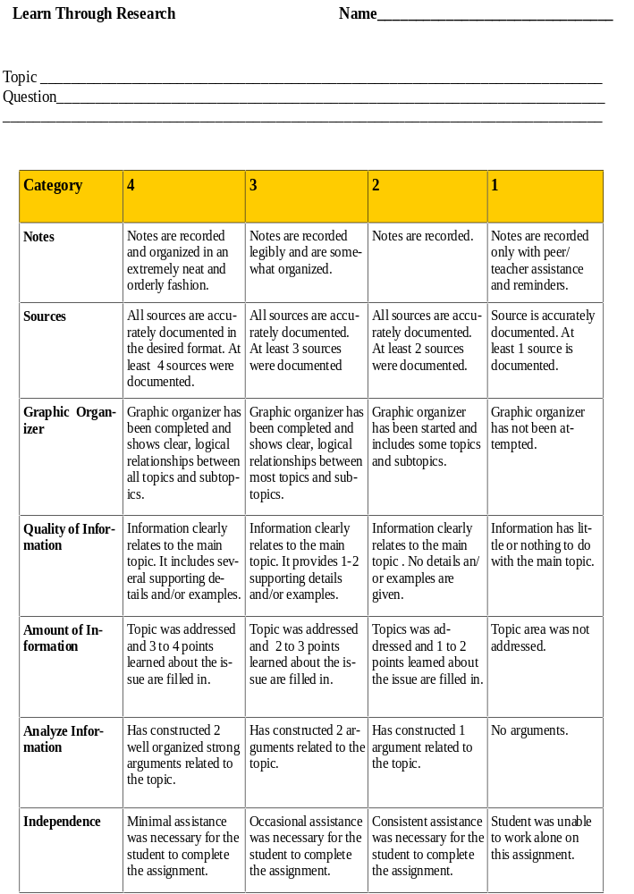


http://www.wisconline.org

Searching the Internet
Author: Leanne Healy
School: Western Wisconsin Technical College Date: 7/14/2004
Description: In this interactive object, learners answer questions about doing research on the Internet.
http://www.wisc-online.com/objects/index_tj.asp?objID=IAT204

I Need More Information Learning Objects

